|  |  |
| --- | --- |
| Submitted By: | **Chee Bo Yu (214322H)** |
|  | **Mark Alfonso Landrito Tuazon (211684G)** |
|  | **Vickneswaran S/O Somu Thevar R (210894T)** |
|  | **Yap Dong Sam (210889C)** |
| PEM Group: | BA2102 |
| Tutor: | Ms Liz Wang |
| Deadline: | 26 Dec 2021 |

ITB421 Data STORAGE ADMINISTRATION

Assignment

Physical Data Modelling

**Table of Contents**

Part 1: OraRental Schema 2-17

Part 2: HardwareLand Schema 18-19

# Part 1: Defining Database Structure and Objects using Database Definition Language (DDL) for OraRental database (20 marks)

**Task 1: Develop DDL statements for creating the tables in the OraRental database**

**Task 2: Creating and Managing Constraints**

**[ Task 1 and Task 2 done together ]**

Creating Tables

|  |  |
| --- | --- |
| Table Name | Command |
| orarent_customers | * CREATE TABLE orarent_customers   (customer_id NUMBER(10) CONSTRAINT ctm_id_nn  NOT NULL CONSTRAINT ctm_id_pk PRIMARY KEY,  last_name VARCHAR2(25) CONSTRAINT l_name_nn NOT NULL,  first_name VARCHAR2(25) CONSTRAINT f_name_nn NOT NULL,  home_phone VARCHAR2(12) CONSTRAINT h_ph_nn NOT NULL,  address VARCHAR2(100) CONSTRAINT addrs_nn NOT NULL,  city VARCHAR2(30) CONSTRAINT city_nn NOT NULL,  state VARCHAR2(2) CONSTRAINT state_nn NOT NULL,  email VARCHAR2(25),  cell_phone VARCHAR2(12)); |
| orarent_movies | * CREATE TABLE orarent_movies   (title_id NUMBER(10) CONSTRAINT mv_title_id_nn NOT NULL CONSTRAINT mv_title_id_pk PRIMARY KEY,  title VARCHAR2(60) CONSTRAINT mv_title_nn NOT NULL,  description VARCHAR2(400) CONSTRAINT mv_desc_nn NOT NULL,  rating VARCHAR2(4) CONSTRAINT mv_rt_ck CHECK(UPPER(rating) IN ('G','PG','PG13','R')),  category VARCHAR2(20) CONSTRAINT mv_ctg_ck CHECK(UPPER(category) IN ('DRAMA', 'COMEDY', 'ACTION', 'CHILD', 'SCIFI', 'DOCUMENTARY')),  release_date DATE CONSTRAINT mv_r_date_nn NOT NULL); |
| orarent_media | * CREATE TABLE orarent_media (   media_id NUMBER(10) CONSTRAINT md_id_nn NOT NULL CONSTRAINT md_id_pk PRIMARY KEY,  format VARCHAR2(3) CONSTRAINT md_fr_nn NOT NULL,  title_id NUMBER(10) CONSTRAINT md_title_id_nn NOT NULL CONSTRAINT md_title_id_fk REFERENCES orarent_movies(title_id)); |
| orarent_rental_history | * CREATE TABLE orarent_rental_history(   media_id NUMBER(10) CONSTRAINT rtl_hty_md_id NOT NULL CONSTRAINT rtl_hty_media_id_fk1 REFERENCES orarent_media(media_id) ,  rental_date DATE DEFAULT SYSDATE CONSTRAINT rtl_hty_date_nn NOT NULL,  customer_id NUMBER(10) CONSTRAINT rtl_hty_ctm_id_nn NOT NULL ,  return_date DATE,  CONSTRAINT rtl_hty_ctm_id_fk2 FOREIGN KEY (customer_id) REFERENCES orarent_customers(customer_id),  CONSTRAINT rtl_hty_md_id_rtl_date_pk PRIMARY KEY (media_id, rental_date)); |
| orarent_actors | * CREATE TABLE orarent_actors(   actor_id NUMBER(10) CONSTRAINT act_id_nn NOT NULL,  stage_name VARCHAR2(40) CONSTRAINT stg_name_nn NOT NULL,  first_name VARCHAR2(25) CONSTRAINT act_f_name_nn NOT NULL,  last_name VARCHAR2(25) CONSTRAINT act_l_name_nn NOT NULL,  birth_date DATE CONSTRAINT b_date_nn NOT NULL,  CONSTRAINT act_id_pk PRIMARY KEY(actor_id)); |
| orarent_star_billings | * CREATE TABLE orarent_star_billings(   actor_id NUMBER(10) CONSTRAINT st_blg_act_id_nn NOT NULL CONSTRAINT st_blg_act_id_fk REFERENCES orarent_actors(actor_id) ,  title_id NUMBER(10) CONSTRAINT st_blg_title_id_nn NOT NULL CONSTRAINT st_blg_title_id_fk REFERENCES orarent_movies(title_id) ,  comments VARCHAR2(40),  CONSTRAINT st_blg_act_id_title_id_pk PRIMARY KEY (actor_id, title_id)); |
| Short Name | ctm = customers  mv = movie  md = media  rtl = rental  rtl_hty = rental history  act = actors  stt_blg = start_billings  nn = not null  fk = foreign key  pk = primary key |

**Run queries from the data dictionaries for the above constraints**

|  |  |
| --- | --- |
| Data Directory | SELECT * FROM user_constraints  WHERE table_name LIKE 'ORARENT%'; |

**Task 3: Creating and Managing Views**

Create a view called TITLE_UNAVAIL to show the movie titles and media_id of the media not returned yet. The view should not allow any DML operations.

**Ans:**

CREATE OR REPLACE VIEW TITLE_UNAVAIL ("Movie Titles", "Media ID")AS

SELECT title, media_id

FROM orarent_movies JOIN orarent_media USING (title_id) JOIN orarent_rental_history USING (media_id)

WHERE return_date > SYSDATE

WITH READ ONLY;

**Result of TITLE_UNAVAIL**

SELECT * FROM TITLE_UNAVAIL;

**Task 4: Working with Sequences (Indexes and Synonyms)**

1. Create the following sequences to be used for primary key values:

CREATE SEQUENCE ora_ctm_pk

INCREMENT BY 1

START WITH 101

MAXVALUE 200

NOCACHE

NOCYCLE;

CREATE SEQUENCE ora_mov_pk

INCREMENT BY 1

START WITH 1

MAXVALUE 50

NOCACHE

NOCYCLE;

CREATE SEQUENCE ora_med_pk

INCREMENT BY 1

START WITH 92

MAXVALUE 200

NOCACHE

NOCYCLE;

CREATE SEQUENCE ora_act_pk

INCREMENT BY 1

START WITH 1001

MAXVALUE 2000

NOCACHE

NOCYCLE;

1. Add the data to the tables using INSERT statements. Be sure to use the sequences for the PKs.

**Inserting Data to Tables**

|  |  |
| --- | --- |
| Table Name | Command |
| orarent_customers | * INSERT INTO ORARENT_CUSTOMERS VALUES   (ora_ctm_pk.NEXTVAL,'Palombo', 'Lisa', '716-270-2669', '123 Main Street, Block 73D #5-217', 'Buffalo', 'NY', 'palombo@ecc.edu',  '716-555-1212')   * INSERT INTO ORARENT_CUSTOMERS VALUES   (ora_ctm_pk.NEXTVAL,'Barack', 'Obama', '716-273-1987', '1600 Pennsylvania Avenue', 'Washington D.C', 'DC', 'obama4president@gmail.com', '716-527-9989')   * INSERT INTO ORARENT_CUSTOMERS VALUES   (ora_ctm_pk.NEXTVAL,'Gaga', 'Lady', '716-143-2798', '30460 Morning View Drive Malibu, CA 90265', 'Malibu', 'CA', 'badromance@heartbreak.com', '716-696-9969')   * INSERT INTO ORARENT_CUSTOMERS VALUES   (ora_ctm_pk.NEXTVAL,'Idol', 'Super', '716-299-9126', '108 Chinatown, Block D77', 'Hawaii', 'HI', 'xiaorong@socialcredit.com', '716-123-4567')   * INSERT INTO ORARENT_CUSTOMERS VALUES   (ora_ctm_pk.NEXTVAL,'The Rock', 'Dwayne', '716-313-5567', '556 Doris Rd', 'El Paso', 'TX', 'drive&power@gym.com', '716-321-7654')   * INSERT INTO ORARENT_CUSTOMERS VALUES   (ora_ctm_pk.NEXTVAL,'Strange', 'Doctor', '716-000-9090', '116 Infinity Stone Rd', 'Marvel', 'MU', 'imanerd@magic.com', '716-444-6678') |
| orarent_movies | * INSERT INTO ORARENT_MOVIES VALUES   (ora_mov_pk.NEXTVAL, 'Remember the Titans', 'The true story of a newly appointed African-American coach and his high school team on their first season as a racially integrated unit.', 'PG', 'DRAMA', '29-SEP-2000')   * INSERT INTO ORARENT_MOVIES VALUES (ora_mov_pk.NEXTVAL, 'Spider-Man: No Way Home', 'With Spider-Man''s identity now revealed, Peter asks Doctor Strange for help. When a spell goes wrong, dangerous foes from other worlds start to appear, forcing Peter to discover what it truly means to be Spider-Man', 'PG13', 'ACTION', '17-DEC-2021'); * INSERT INTO ORARENT_MOVIES VALUES (ora_mov_pk.NEXTVAL, 'The Matrix Resurrections', 'Return to a world of two realities: one, everyday life; the other, what lies behind it. To find out if his reality is a construct, to truly know himself, Mr. Anderson will have to choose to follow the white rabbit once more.', 'R', 'SCIFI', '22-Dec-2021'); * INSERT INTO ORARENT_MOVIES VALUES (ora_mov_pk.NEXTVAL, 'West Side Story', 'An adaptation of the 1957 musical, West Side Story explores forbidden love and the rivalry between the Jets and the Sharks, two teenage street gangs of different ethnic backgrounds.', 'PG13', 'DRAMA', '10-Dec-2021'); * INSERT INTO ORARENT_MOVIES VALUES (ora_mov_pk.NEXTVAL, 'House of Gucci', 'House of Gucci is inspired by the family empire behind the Italian fashion house of Gucci. When Patrizia Reggiani (Lady Gaga), an outsider from humble beginnings, marries into the Gucci family, her unbridled ambition begins to unravel the family legacy and triggers a reckless spiral of betrayal, decadence, revenge, and ultimately...murder.', 'R', 'DRAMA', '24-Nov-2021'); * INSERT INTO ORARENT_MOVIES VALUES (ora_mov_pk.NEXTVAL, 'The Last Duel', 'Based on the true story of France''s last trial by combat in the Middle Ages. Knight Jean de Carrouges challenges his former friend Jacques Le Gris to a duel after Jean''s wife Marguerite accuses Le Gris of rape. Told in multiple "Rashomon-style" points of view.', 'R', 'ACTION', '15-Oct-2021'); |
| orarent_media | * INSERT INTO ORARENT_MEDIA VALUES(ora_med_pk.NEXTVAL, 'DVD', 1); * INSERT INTO ORARENT_MEDIA VALUES(ora_med_pk.NEXTVAL, 'VHS', 1); * INSERT INTO ORARENT_MEDIA VALUES(ora_med_pk.NEXTVAL, 'DVD', 2); * INSERT INTO ORARENT_MEDIA VALUES(ora_med_pk.NEXTVAL, 'DVD', 3); * INSERT INTO ORARENT_MEDIA VALUES(ora_med_pk.NEXTVAL, 'VHS', 3); * INSERT INTO ORARENT_MEDIA VALUES(ora_med_pk.NEXTVAL, 'VHS', 4); * INSERT INTO ORARENT_MEDIA VALUES(ora_med_pk.NEXTVAL, 'DVD', 5); * INSERT INTO ORARENT_MEDIA VALUES(ora_med_pk.NEXTVAL, 'DVD', 6); * INSERT INTO ORARENT_MEDIA VALUES(ora_med_pk.NEXTVAL, 'MP4', 6); |
| orarent_rental_history | * INSERT INTO orarent_rental_history VALUES(96, DEFAULT, 104,'02-MAR-2022'); * INSERT INTO orarent_rental_history VALUES(92, '19-SEP-2010', 101,'20-SEP-2010'); * INSERT INTO orarent_rental_history VALUES(93, '01-JUN-2011', 106,'01-JUL-2011'); * INSERT INTO orarent_rental_history VALUES(95, '15-APR-2011', 105,'19-MAY-2011'); * INSERT INTO orarent_rental_history VALUES(98, '08-APR-2017', 102,'30-AUG-2017'); |
| orarent_actors | * INSERT INTO orarent_actors VALUES(ora_act_pk.NEXTVAL, 'Brad Pitt', 'William', 'Pitt', '18-DEC-1963'); * INSERT INTO orarent_actors VALUES(ora_act_pk.NEXTVAL, 'Doctor Strange', 'Benedict', 'Cumberbatch', '19-JUL-1976'); * INSERT INTO orarent_actors VALUES(ora_act_pk.NEXTVAL, 'Orange', 'Donald', 'Trump', '19-JUN-1946'); * INSERT INTO orarent_actors VALUES(ora_act_pk.NEXTVAL, 'MahJong', 'Joe', 'Maama', '21-Nov-1969'); * INSERT INTO orarent_actors VALUES(ora_act_pk.NEXTVAL, 'Doja Cat', 'Amala', 'Ratna', '21-Oct-1995'); |
| orarent_star_billings | * INSERT INTO orarent_star_billings VALUES(1001, 2, 'Romantic Lead'); * INSERT INTO orarent_star_billings VALUES(1002, 1, 'Inspiring Coach'); * INSERT INTO orarent_star_billings VALUES(1003, 4, 'Outstanding Acting'); * INSERT INTO orarent_star_billings VALUES(1004, 3, 'Profound Acting'); * INSERT INTO orarent_star_billings VALUES(1005, 5, 'Purr~fect Acting'); |

1. Create an index on the last_name column of the Customers table

**Ans:**

CREATE INDEX ctm_last_name_index

on orarent_customers(last_name);

Create a synonym called TU for the TITLE_UNAVAIL view.

**Ans:**

CREATE SYNONYM TU

FOR title_unavail;

**Result for Synonym called TU**

SELECT * FROM TU;

Sample Data for **ORARENT_CUSTOMERS**

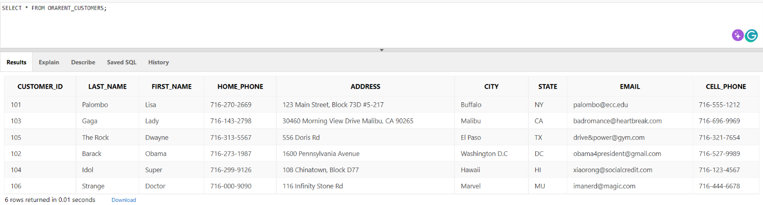

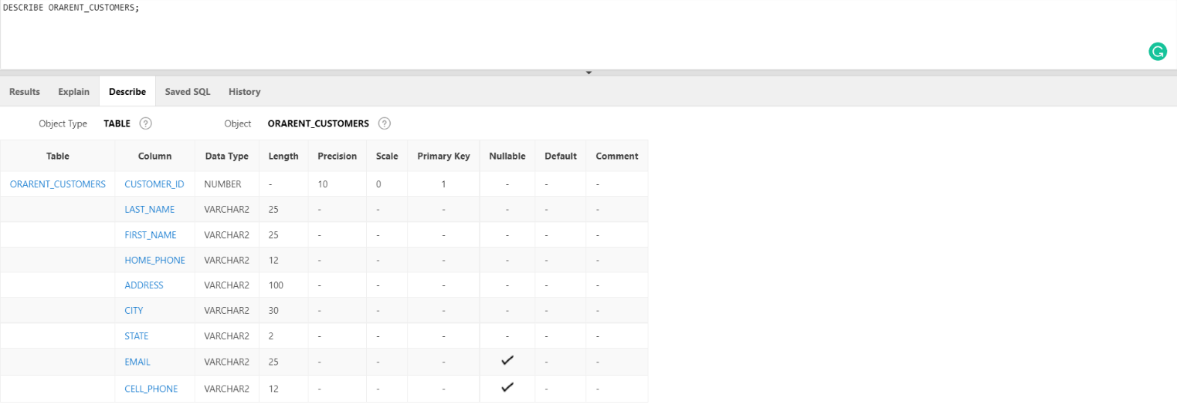

Sample Data for **ORARENT_MOVIES**

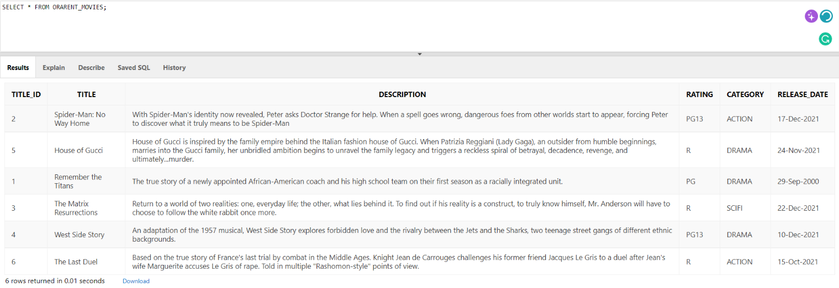

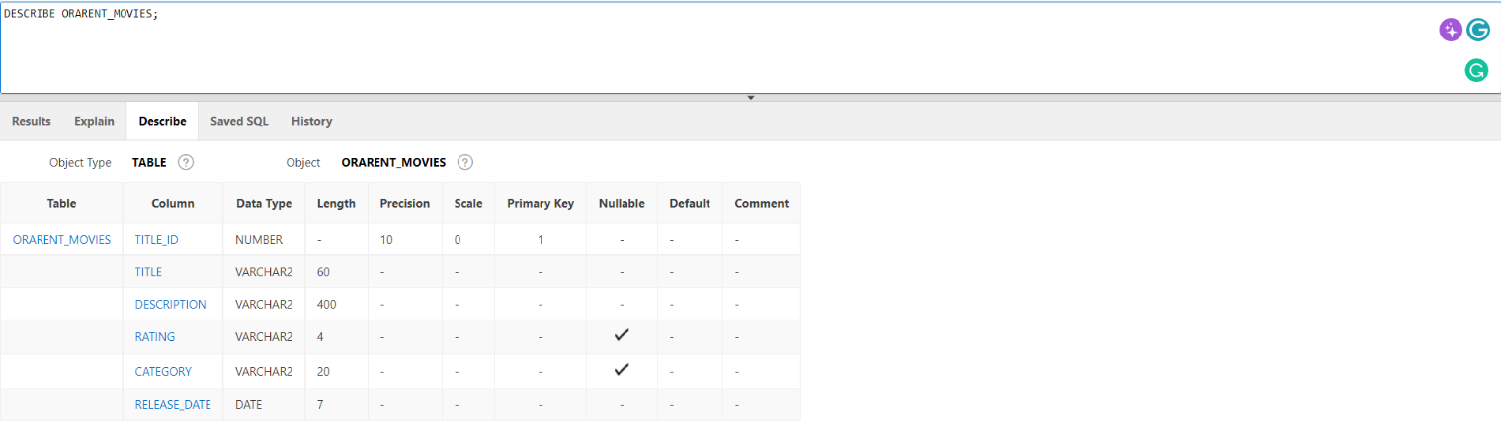

Sample Data for **ORARENT_MEDIA**

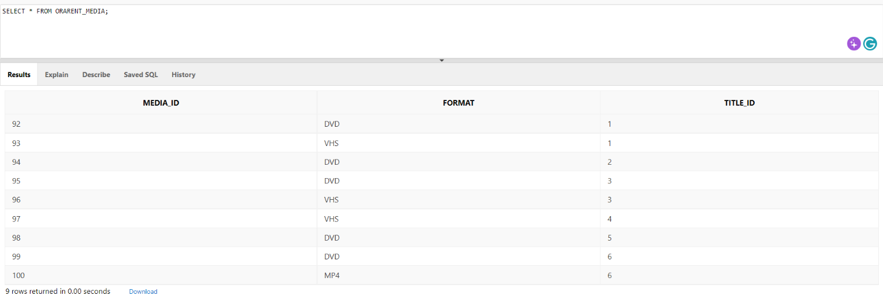

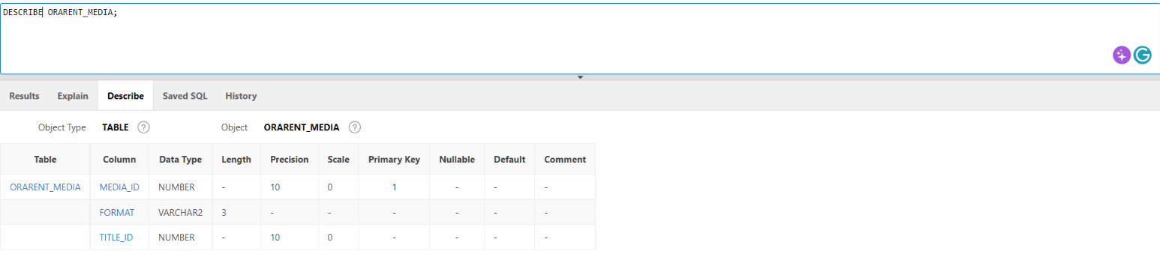

Sample Data for **ORARENT_RENTAL_HISTORY**

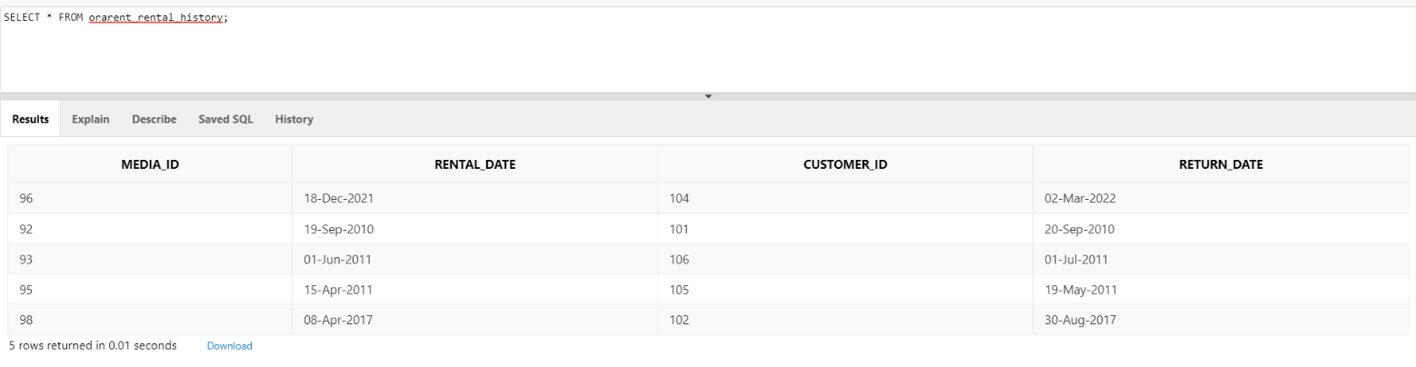

Sample Data for **ORARENT_ACTORS**

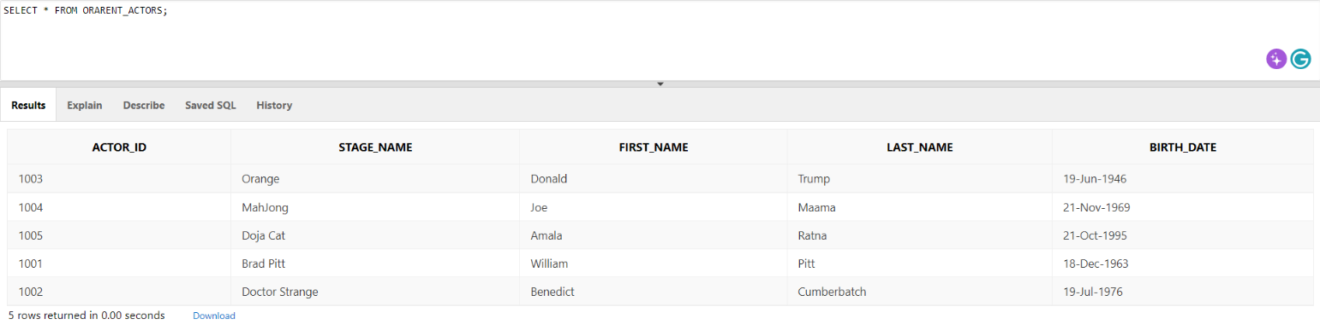

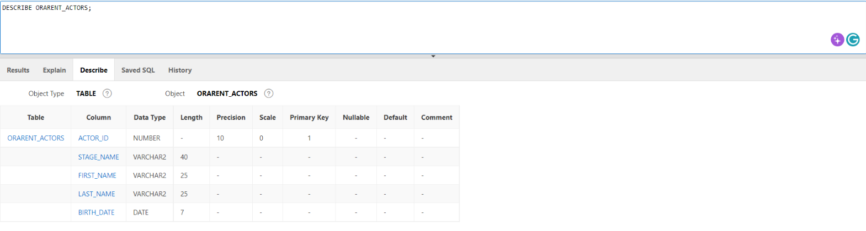

Sample Data for **ORARENT_STAR_BILLINGS**

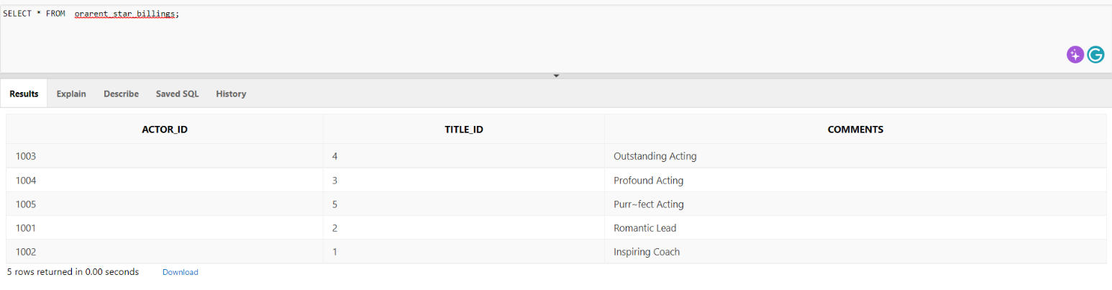

# Part 2: Perform data retrieval and manipulation tasks specified in the email correspondences with users (20 marks)

1. List of the SQL statements executed by the team. For each request, please indicate the team member who responded to it.

|  |  |  |
| --- | --- | --- |
| **Name** | **Script** | **Task** |
| Bo Yu | **Request 1**  **UPDATE HWL_EMPLOYEES**  **SET EMAIL ='ellis.washington@oracle.com', MANAGER_ID = 1**  **WHERE FIRST_NAME= 'Ellis';**  **SELECT**  **EMPLOYEE_ID,FIRST_NAME,LAST_NAME,EMAIL,MANAGER_ID FROM HWL_EMPLOYEES**  **WHERE FIRST_NAME = 'Ellis';** | Request 1  Update the email address of the employee “Ellis Washington” to ellis.washington@oracle.com |
| Bo Yu | **Request 2**  **SELECT e.FIRST_NAME AS "First Name", e.LAST_NAME AS "Last Name", LPAD(SUBSTR(e.NRIC,6,5),9,'*') AS "NRIC", e.HIRE_DATE AS "Hire Date", m.FIRST_NAME||' '|| m.LAST_NAME AS "Manager Name"**  **FROM HWL_EMPLOYEES e**  **LEFT OUTER JOIN HWL_EMPLOYEES m**  **ON (e.MANAGER_ID = m.EMPLOYEE_ID)**  **WHERE e.JOB_TITLE = 'Stock Clerk';** | Request 2  Retrieve the list of our employees whose job title is Stock Clerk. The data column in the report should be displayed in this sequence, First Name, Last Name, NRIC, Hire Date and Manager Name. |
| Vicknesh | **Request 1**  **UPDATE HWL_CUSTOMERS**  **SET CREDIT_LIMIT=7000**  **WHERE  ADDRESS  LIKE '%Wisconsin%';**  **SELECT CUSTOMER_ID AS "Customer ID", NAME AS "Customer Name", ADDRESS AS "Address", WEBSITE AS "Website", CREDIT_LIMIT AS "Credit Limit (USD)"**  **FROM HWL_CUSTOMERS**  **WHERE  ADDRESS  LIKE '%Wisconsin%';** | Request 1  Update the credit limit of all the customers located in Wisconsin (WI) to USD 7000. |
| Vicknesh | **Request 2**  **SELECT CUSTOMER_ID AS "Customer ID", NAME AS "Customer Name", ADDRESS AS "Address", CREDIT_LIMIT AS "Credit Limit (USD)", FIRST_NAME AS "First Name", LAST_NAME AS "Last Name"**  **FROM HWL_CUSTOMERS JOIN HWL_CONTACTS USING (CUSTOMER_ID)**  **WHERE CUSTOMER_ID**  **BETWEEN 140 AND 155**  **ORDER BY CUSTOMER_ID;BETWEEN 140 AND 155**  **ORDER BY CUSTOMER_ID,NAME,ADDRESS,CREDIT_LIMIT,FIRST_NAME,**  **LAST_NAME,PASSWORD;** | Request 2  Retrieve the list of customers and their contact details with customer id between 140 to 155. The data column in the report should be displayed in this sequence, Customer ID, Customer Name, Address, Credit Limit, First Name, Last Name and Password.  (Address & Password sensitive information, can’t be sent via Email) |
| Sam | **Request 1**  **UPDATE HWL_INVENTORIES**  **SET QUANTITY = 50**  **WHERE WAREHOUSE_ID = 9 AND PRODUCT_ID = 137;** | Request 1  Update the inventory quantity of Asus Z10PE-D16 WS in Bombay warehouse to 50. |
| Sam | **Request 2**  **SELECT ORDER_ID AS "Order Number", COUNT(QUANTITY) AS "Single/Multiple Time Orders"**  **FROM HWL_ORDER_ITEMS**  **WHERE QUANTITY < 200**  **GROUP BY ORDER_ID**  **HAVING COUNT(QUANTITY) = 1**  **ORDER BY ORDER_ID;** | Request 2  Retrieve the list of Order IDs with less than 200 items purchased in a single order. |
| Mark | **Request 1**  **UPDATE HWL_EMPLOYEES**  **SET JOB_TITLE = 'Sales Manager', MANAGER_ID = (SELECT EMPLOYEE_ID FROM HWL_EMPLOYEES WHERE FIRST_NAME = 'Tommy')**  **WHERE FIRST_NAME = 'Lily';**  **SELECT EMPLOYEE_ID, FIRST_NAME || ' ' || LAST_NAME AS "Full Name", MANAGER_ID, JOB_TITLE**  **FROM HWL_EMPLOYEES**  **WHERE EMPLOYEE_ID IN (54,1);** | Request 1  Lily Fisher has been promoted to Sales Manager and reporting to Tommy Bailey, please update her job title and manager in the database accordingly. |
| Mark | **Request 2**  **SELECT E.FIRST_NAME AS "First Name", E.LAST_NAME AS "Last Name", E.HIRE_DATE AS "Hire Date", LPAD(SUBSTR(E.NRIC,6,5),9,'*') AS NRIC, CONCAT(M.FIRST_NAME || ' ', M.LAST_NAME) AS "Manager Name"**  **FROM HWL_EMPLOYEES E JOIN HWL_EMPLOYEES M ON (E.MANAGER_ID = M.EMPLOYEE_ID)**  **WHERE E.JOB_TITLE = 'Stock Clerk';** | Request 2  Retrieve the list of our employees whose job title is Stock Clerk. The data column in the report should be displayed in this sequence, First Name, Last Name, Hire Date, the last four digit of NRIC and Manager Name. |